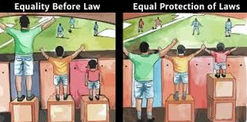**Questions**

1. The concepts of "Equality Before Law" and "Equal Protection of Law" are enshrined in which article of the Indian Constitution?

* (A) Article 13
* (B) Article 14
* (C) Article 15
* (D) Article 16

**Correct Answer:** (B) Article 14

1. 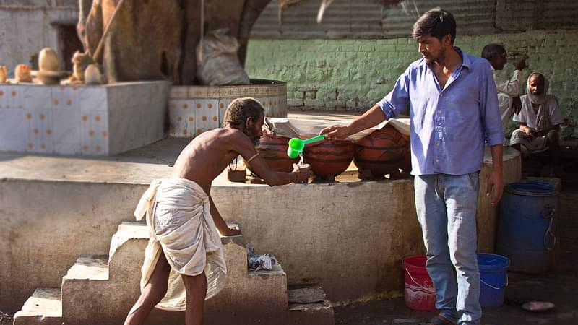

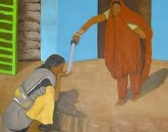  
Under Article 17 of the Indian Constitution, which of the following is prohibited?

* (A) Discrimination based on religion
* (B) Untouchability in any form
* (C) Inequality in education
* (D) Denial of voting rights

**Correct Answer:** (B) Untouchability in any form

1. 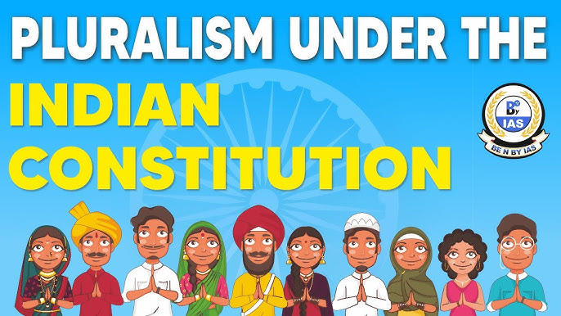   
   Which article of the Indian Constitution prohibits discrimination on the grounds of religion, race, caste, sex, or place of birth?

* (A) Article 14
* (B) Article 15
* (C) Article 16
* (D) Article 17

**Correct Answer:** (B) Article 15

1. 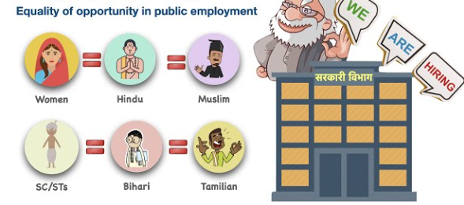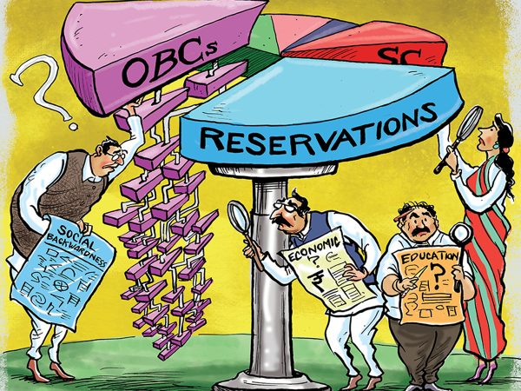

Which article of the Indian Constitution best explains equality of opportunity in public employment, as depicted in the above image?

* (A) Article 14
* (B) Article 15
* (C) Article 16
* (D) Article 17

**Correct Answer:** (C) Article 16



You, as a Government Aadhaar officer, ask a person for their name, and they reply, "My name is Maharaja Adhiraj Singh." According to the Indian Constitution, which article prohibits the use of titles like "Maharaja" for official purposes?

* (A) Article 14
* (B) Article 15
* (C) Article 18
* (D) Article 16

**Correct Answer:** (C) Article 18

1. 

The image above, depicting a person with a red tape marked 'FREEDOM' over their mouth, represents a restriction on which of the following fundamental rights?

* (A) Article 19(1)(a) - Right to Freedom of Speech and Expression
* (B) Article 20(1) - Protection Against Conviction for Offences
* (C) Article 22(1) - Protection Against Arrest and Detention in Certain Cases
* (D) Article 23 - Prohibition of Traffic in Human Beings and Forced Labour

**Correct Answer:** (A) Article 19(1)(a) - Right to Freedom of Speech and Expression



You are a lawyer defending your client who was forced by the police to self-incriminate during questioning. Which article of the Indian Constitution would you use to defend your client in court?

* (A) Article 14
* (B) Article 15
* (C) Article 18
* (D) Article 20(3)

**Correct Answer:** (D) Article 20(3)

You are a lawyer defending your client who has been arrested by the police for the same crime twice. Which article of the Indian Constitution will you use to defend your client against being prosecuted again for the same offense?

* (A) Article 14
* (B) Article 15
* (C) Article 16
* (D) Article 20(2)

**Correct Answer:** (D) Article 20(2)